Assignment 3

Biometric Attendance System [ Face ,Fingerprint ] – Shruti Building

1. Introduction
A Biometric Attendance System is a smart system with IoT technology application that relies on distinct human characteristics like fingerprints and facial recognition to capture attendance information. This system used in Shruti Building involves multi-modal biometrics which incorporate fingerprint scanning and face recognition for more accuracy and robustness.
The Biometric Attendance System operates through an IoT-edge+cloud system involving capturing, processing, storage, and accessing of information using sensors, software dashboards, and cloud.

2. Architecture of System & Principles of Operation
- The working principle is based on a well-designed pipeline system:
- Overall Flow of Operations
- Data Acquisition -> Processing -> Storage -> Access
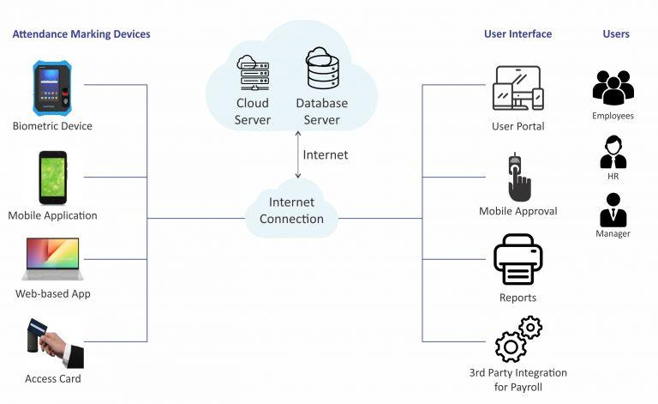
Working Details
- Data Acquisition
  - Acquisition of face image using camera
  - Biometric scanning of fingerprint
- Processing
  - Features from images extracted
  - Converting raw data to template data through algorithm
- Storage
  - Storage in local/cloud database
  - Individual ID for each person
- Access
  - Attendance details seen by admin through software/dashboard
  - Instant report generation
The above structure makes the entire operation process rapid and automated.

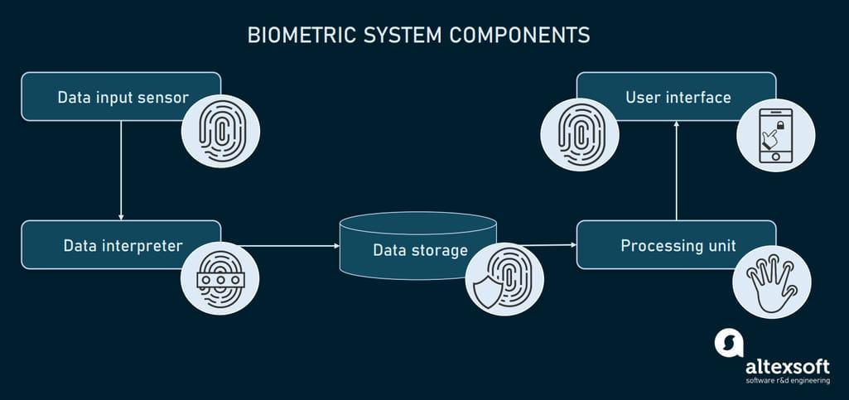

3. Face Recognition: Sensing Devices & Equipment
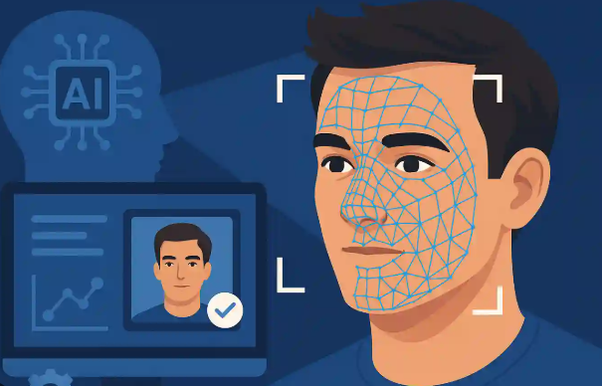
Face recognition technology employs high-end imaging devices.
Main Components
- Facial images acquisition
- Higher resolution increases precision
  - IR (Infrared) Sensor
- Face detection even under dim lighting conditions
- Aids in anti-spoofing
  - Depth Sensor (3D Sensor)
- Face depth and geometry measurement
- Buffers against image-based attack attempts
  - Processor (Edge Device)
- Face recognition process
  - Camera (RGB Camera)

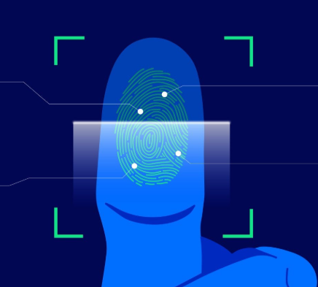
4. Fingerprint Recognition: Sensors and Modules

Fingerprint recognition uses thumb prints.
Types of Fingerprint Sensors
- Optical Fingerprint Sensor
- It takes an image of the fingerprint with light.
- It is commonly used and inexpensive.
- Capacitive Fingerprint Sensor
- It identifies fingerprints through electrical signals.
- It is more accurate and secure.
- Modules Supporting Fingerprints
- Microprocessor/Controller
- Memory for saving fingerprint information
- Fingerprint sensors offer high accuracy and uniqueness.

5. Multi-Modal Biometrics Integration (Face + Fingerprint)

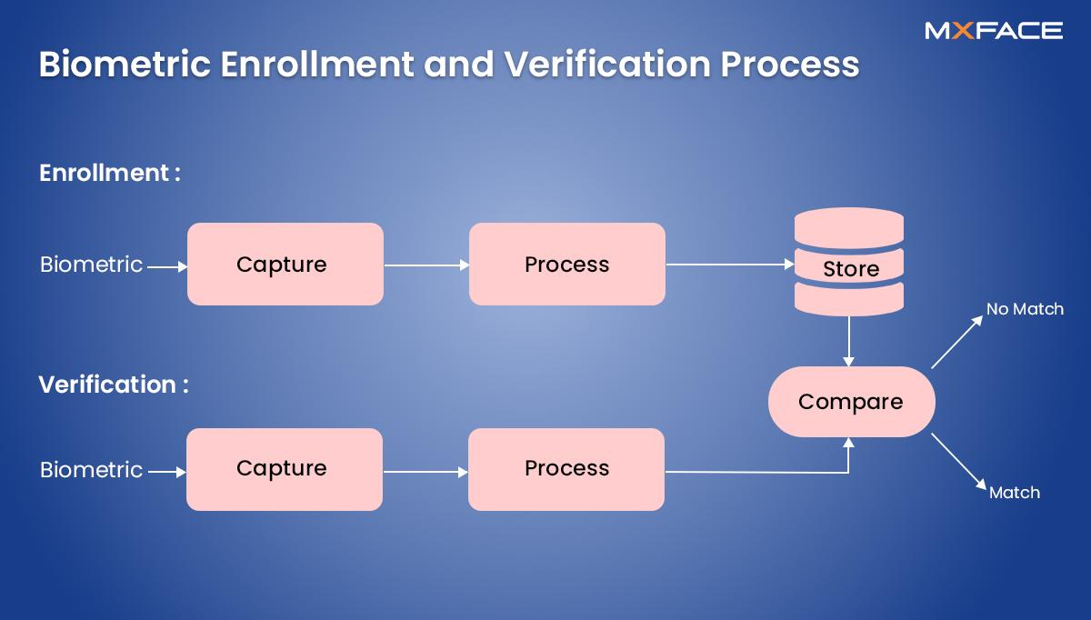
Both the modes are integrated in order to enhance efficiency.
Integration Process
• User presents face/fingerprint
• Both the modes are processed by system
• Matching is done independently
• The final identification decision depends on:
o At least one match (OR logic)
o Both match (AND logic for improved security)
Benefits
• Increased accuracy
• Less errors
• More security from spoof attacks
Multi-modal biometrics make the system more robust compared to other types of systems.

6. Data Flow in the System
Data flow within the system is well-structured and includes the following process:
Step-wise Data Flow Process
• Acquisition
o Face and fingerprint images collection
• Feature Extraction
o Feature extraction (facial and fingerprint patterns)
• Matching
o Comparison of extracted features with database templates
• Database/Storage
o Attendance records and user information storage.

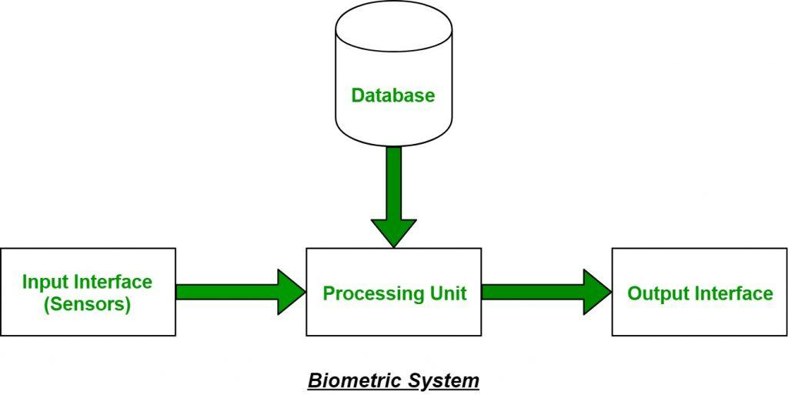

7. Networking, Protocols, and Backend/Cloud Interactions
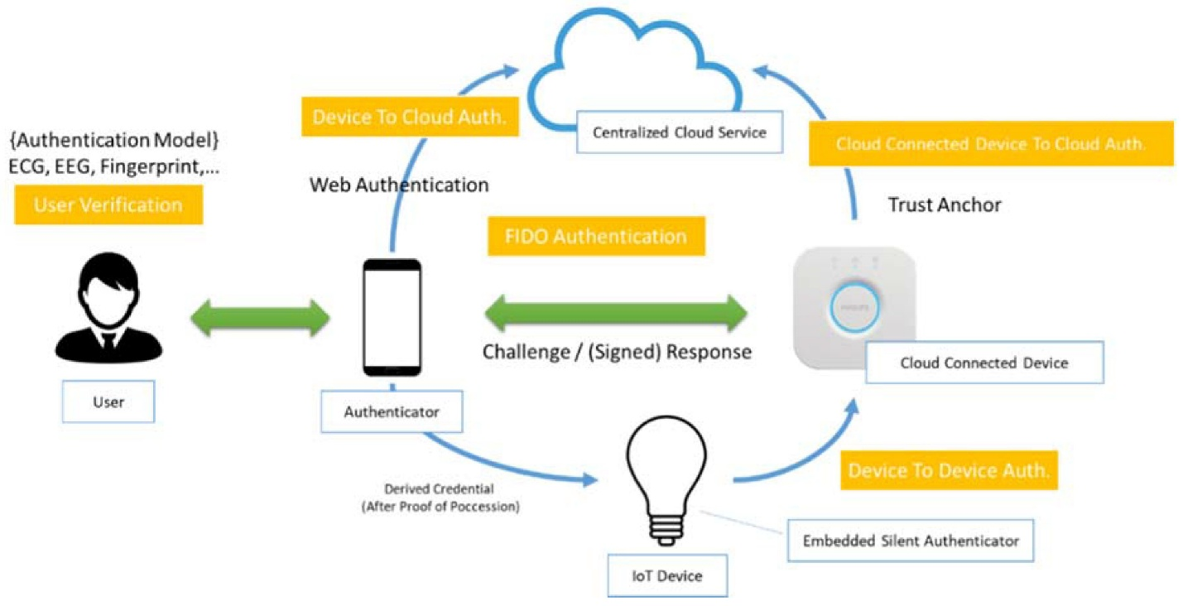
As an IoT device, it interfaces with networks and cloud systems.
Network Components
• Wi-Fi/Ethernet Connectivity
• Local Server or Cloud Server
Used Protocols
• HTTP/HTTPS – To communicate with server
• MQTT (IoT protocol) – For real-time data exchange
• TCP/IP - Basic Communication Protocol
Backend/Cloud Tasks
• Biometric Template Storage
• Attendance Record Keeping
• Dashboarding and Reporting
• Remote Access Facility
Networking makes possible real-time monitoring and centralization of processes.

8. Important Considerations
1. Precision
• Very accurate in recognizing people
• Multi-modal design eliminates errors
2. Latency
• Rapid response (within a few seconds)
• Edge Computing speeds up process
3. Anti-Spoofing Features
• IR/Depth Sensors for fake faces
• Capacitive Sensors for fingerprint spoofing
4. Security and Privacy Measures
• Data Encryption (HTTPS/SSL)
• Biometric Templates Stored Securely
• Limited Access Only To Authorized Users

9.Conclusion
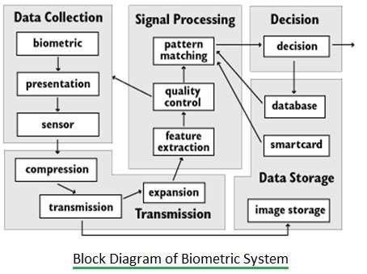
Shruti Building Biometric Attendance System is an intelligent IoT-based system that uses face recognition and fingerprint recognition. With its efficient data capture, processing, storage, and retrieval process through IoT network connectivity, the system ensures reliable and secure attendance management.
• Uses face + fingerprint (multi-modal biometrics)
• Follows data flow process (data capture, processing, storage, access)
• Uses IoT network technology
• Highly accurate and secure

